Hemangi Santosh Sawant

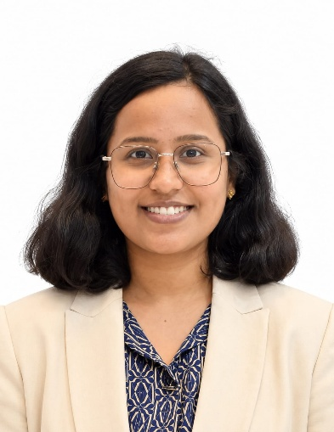

MSc Health Informatics and Analytics | Chancellor’s Gold Medal Recipient
Hemangi Santosh Sawant is an accomplished alumnus of The Apollo University, Chittoor, with a strong academic record and a growing interest in the intersection of healthcare, technology, data, and innovation. Her academic journey reflects dedication, excellence, and a passion for applying emerging technologies to address challenges in healthcare.
Hemangi was honoured with the Chancellor’s Gold Medal from The Apollo University, Chittoor, in 2025, recognising her outstanding academic performance. This prestigious distinction places her among the university's highest-achieving students and reflects her consistent commitment to academic excellence, discipline, and learning.
Her journey also demonstrates a strong inclination towards research and innovation. In 2024, she received the Best Paper Award at the National Conference on AI & ML in Digital Health Transformation & Social Sciences, VR & AR, organised by the Tata Institute of Social Sciences (TISS), Mumbai. The award recognised research carried out in collaboration with Sri Prajna Varma, under the guidance of Dr. Gopi Krishna and Dr. Subhadra. This achievement highlights her ability to engage with emerging technologies and explore their potential applications in the evolving field of digital healthcare.
Adding to her achievements, Hemangi was part of the winning team at Solvathon 2024, held during the 11th International THIT in Bengaluru. She collaborated with Sri Prajna Varma and GCM Jyothi, under the guidance of Dr. Sriroop and Dr. Aditya. Her success in this innovation-oriented competition reflects her ability to work collaboratively, approach challenges creatively, and contribute to solution-oriented initiatives.
With her strong academic foundation, research exposure, and demonstrated interest in technology-driven healthcare, Hemangi represents the growing generation of professionals who are contributing to the transformation of healthcare through health informatics, analytics, artificial intelligence, and digital innovation.

Key Achievements
- 🏅 Chancellor’s Gold Medal – The Apollo University, Chittoor (2025) for outstanding academic performance.
- 🏆 Best Paper Award – National Conference on AI & ML in Digital Health Transformation & Social Sciences, VR & AR, TISS Mumbai (2024).
- 🥇 Winner – Solvathon 2024, 11th International THIT, Bengaluru.
- 🔬 Research experience in the emerging field of AI and digital health.
- 🤝 Demonstrated collaborative and innovative problem-solving through research and competitive technology initiatives.

Areas of Interest
Health Informatics | Healthcare Analytics | Digital Health | Artificial Intelligence & Machine Learning | Healthcare Innovation

An Inspiring Academic Journey
Hemangi's journey is a reflection of how academic excellence, research curiosity, teamwork, and innovation can come together to create meaningful professional opportunities. From achieving the university's prestigious Chancellor’s Gold Medal to receiving recognition at a national-level conference and winning an international technology-focused competition, her accomplishments demonstrate a strong foundation for continued growth in the field of health informatics and analytics.
Her achievements serve as an inspiration to students of Biomedical Sciences and allied health disciplines, encouraging them to pursue excellence not only in academics but also in research, innovation, collaboration, and emerging areas of healthcare technology.

